**(Utilization of a Constrained Resources)**

The Walton Toy Company manufactures a line of dolls and a doll dress sewing kit. Demand for the dolls is increasing, and management requests assistance from you in determining an economical sales and production mix for the coming year. The company has provided the following data:

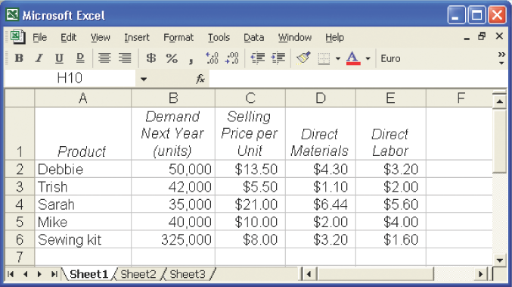

The following additional information is available:

1. The company's plant has a capacity of 130,000 direct labor-hours per year on a single-shift basis. The company's present employees and equipment can produce all five products.
2. The direct labor rate of $8 per hour is expected to remain unchanged during the coming year.
3. Fixed costs total $520,000 per year. Variable overhead costs are $2 per direct labor-hour.
4. All of the company's nonmanufacturing costs are fixed.
5. The company's finished goods inventory is negligible and can be ignored.

***Required: (Write down your answer at the backside)***

1. Determine the contribution margin per direct labor-hour expended on each product.
2. Prepare a schedule showing the total direct labor-hours that will be required to produce the units estimated to be sold during the coming year.
3. Examine the data you have computed in (1) and (2) above. How would you allocate the 130,000 direct labor hours of capacity to Walton Toy Company's various products?
4. What is the highest price, in terms of a rate per hour, that Walton Toy Company would be willing to pay for additional capacity (that is, for added direct labor time)?

**Your answers:**